API

#### **1. Upload Video and Metadata**

This endpoint handles both the video file and the associated metadata (such as title, description) in one request from the UI.

POST /upload

Content-Type: multipart/form-data

{

"title": "My Awesome Video",

"description": "An awesome video upload",

"file": (binary video data),

"file_format": "mp4",

"file_size": 123456789

}

**Action**:

* The API server receives the video file and metadata.
* Uploads the video to **Original Storage**.
* Stores the metadata in the **NoSQL Metadata DB**.
* Initiates the transcoding process.

‘Response

{

"video_id": "video123",

"message": "Transcoding complete, video ready for streaming"

}

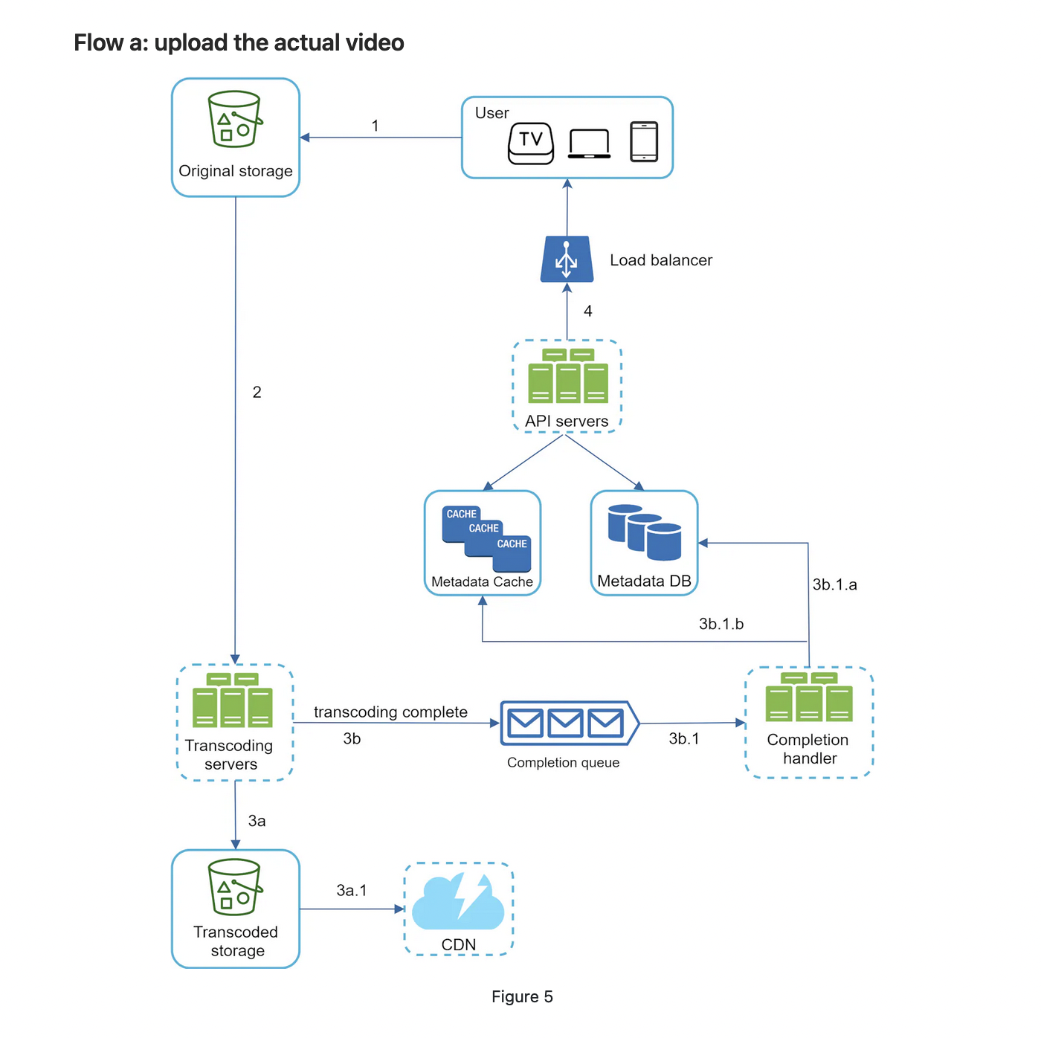

Figure 5 shows how to upload the actual video. The explanation is shown below:

1. Videos are uploaded to the original storage.

2. Transcoding servers fetch videos from the original storage and start transcoding.

3. Once transcoding is complete, the following two steps are executed in parallel:

* 3a. Transcoded videos are sent to transcoded storage.
* 3b. Transcoding completion events are queued in the completion queue.  
    
   3a.1. Transcoded videos are distributed to CDN.  
    
   3b.1. Completion handler contains a bunch of workers that continuously pull event data from the queue.  
    
   3b.1.a. and 3b.1.b. Completion handler updates the metadata database and cache when video transcoding is complete.

4. API servers inform the client that the video is successfully uploaded and is ready for streaming.

### **Schema for Metadata Table (NoSQL DB)**

Here's a schema that could be used in a **NoSQL database** like DynamoDB for storing video metadata:

| **Field** | **Data Type** | **Description** |
| --- | --- | --- |
| video_id | String (PK) | Unique ID for the video. |
| title | String | Title of the video. |
| description | String | Description of the video. |
| user_id | String | ID of the user who uploaded the video. |
| upload_status | String | Status of the upload (uploaded, transcoding, complete). |
| original_file_url | String | URL of the uploaded video in **Original Storage**. |
| transcoded_files | List<Object> | List of transcoded files with resolutions and CDN URLs. |
| file_format | String | Format of the uploaded file (e.g., mp4). |
| file_size | Number | Size of the video file in bytes. |
| duration | Number | Duration of the video (in seconds). |
| created_at | String (ISO) | Timestamp when the video was uploaded. |
| transcoding_progress | Number | Progress of transcoding (e.g., 50%). |
| cdn_urls | List<String> | URLs pointing to CDN for streaming transcoded versions. |
| resolution | String | Video resolution after transcoding (e.g., 1080p). |

### **Metadata Cache Schema**

The **Metadata Cache** (e.g., Redis or Memcached) would be a simplified version of the metadata that is frequently accessed by the system. It contains the basic information needed to serve the video quickly, without querying the database.

| **Field** | **Data Type** | **Description** |
| --- | --- | --- |
| video_id | String (PK) | Unique ID for the video. |
| title | String | Title of the video. |
| transcoded_files | List<Object> | URLs and resolutions of the transcoded files for quick access. |
| upload_status | String | Status of the upload. |
| cdn_urls | List<String> | URLs for streaming via CDN. |

Video Streaming

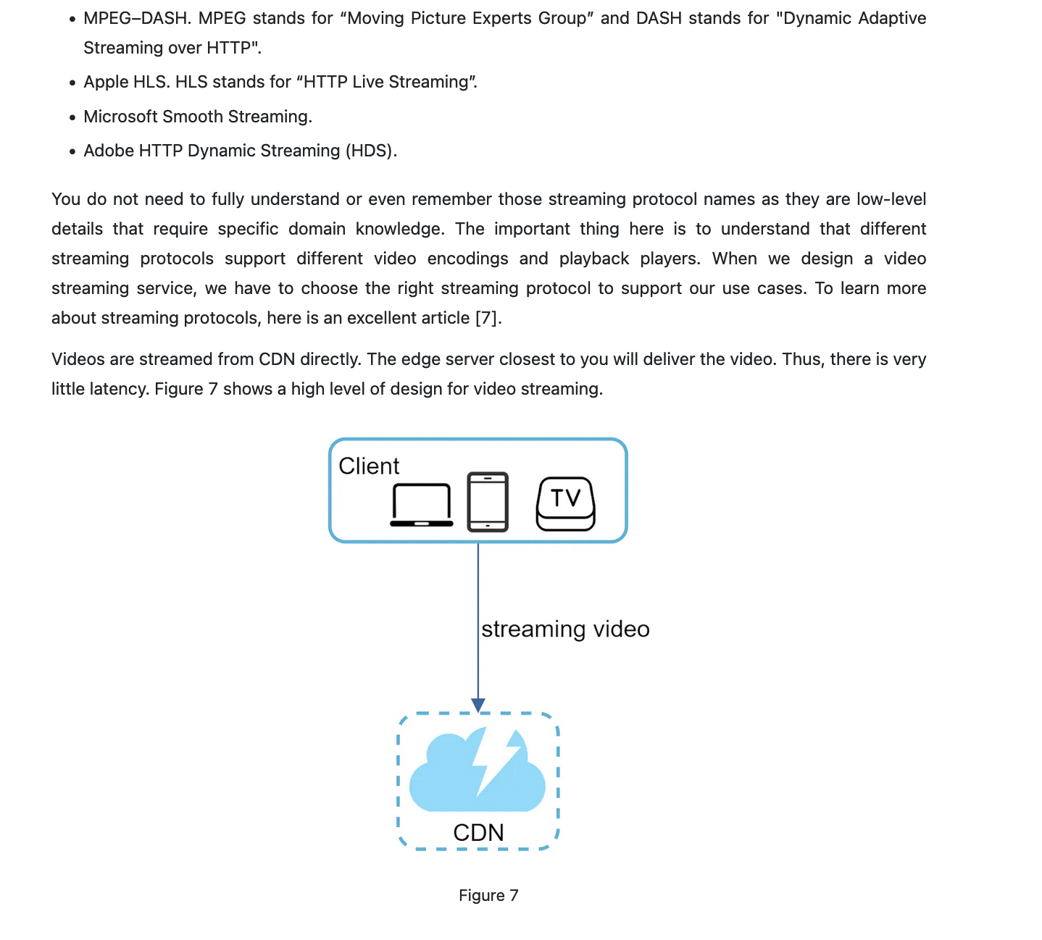

System design on video transcoder

Cost..

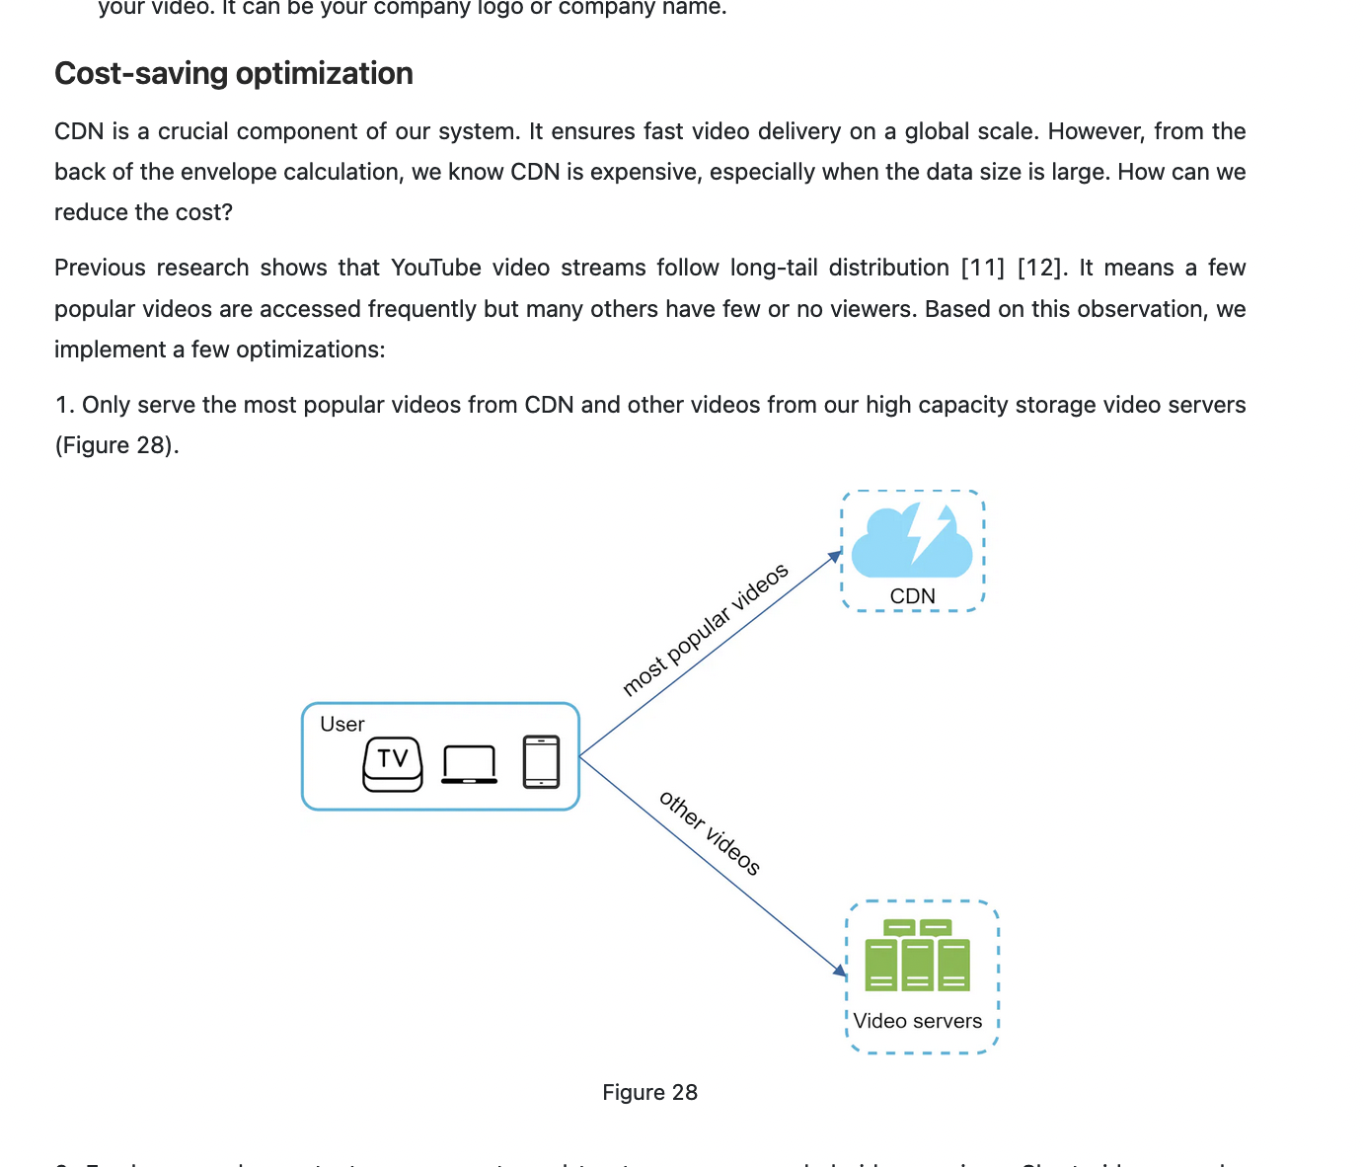

Harkirat video transcoding

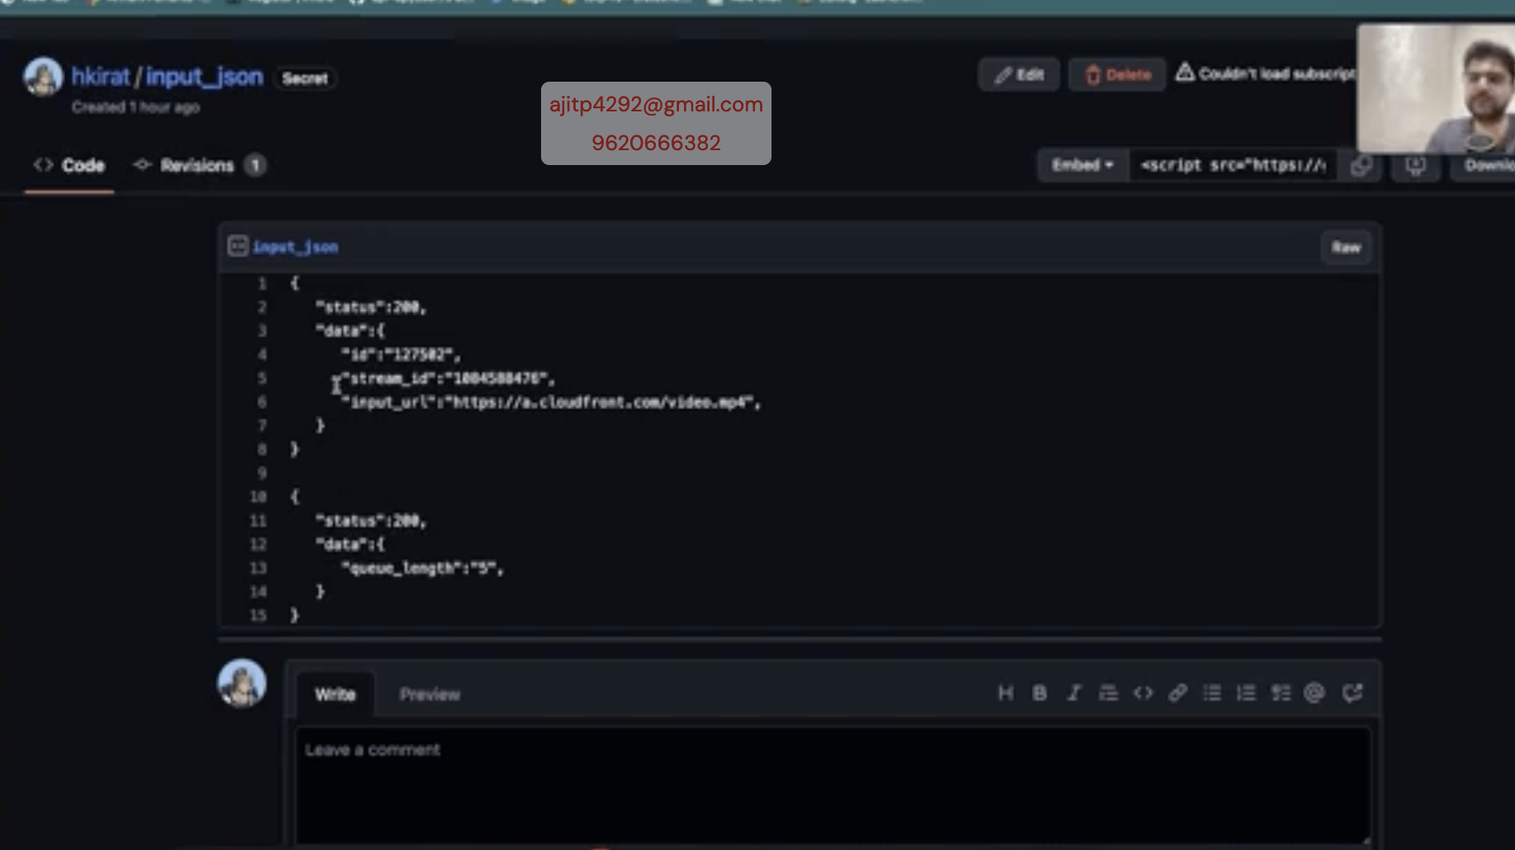

Pull approach, to be transcoded in queue.

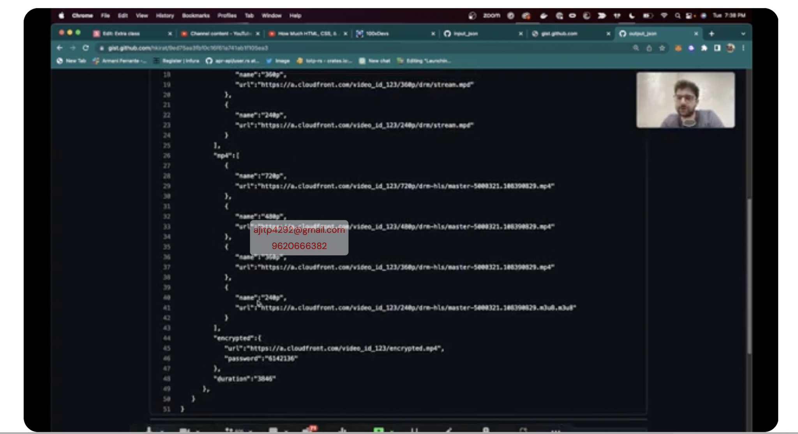

Response of transcoder

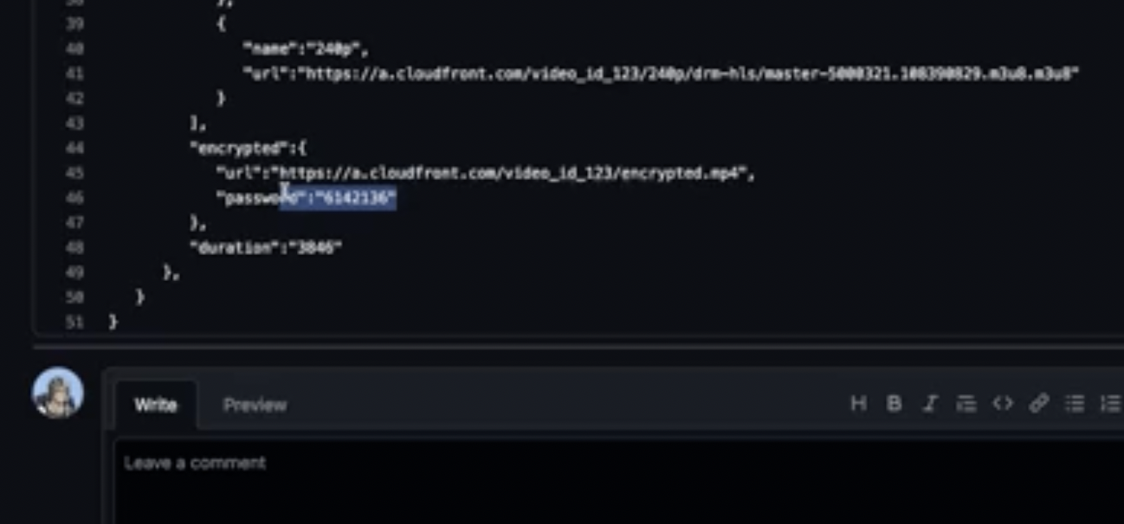

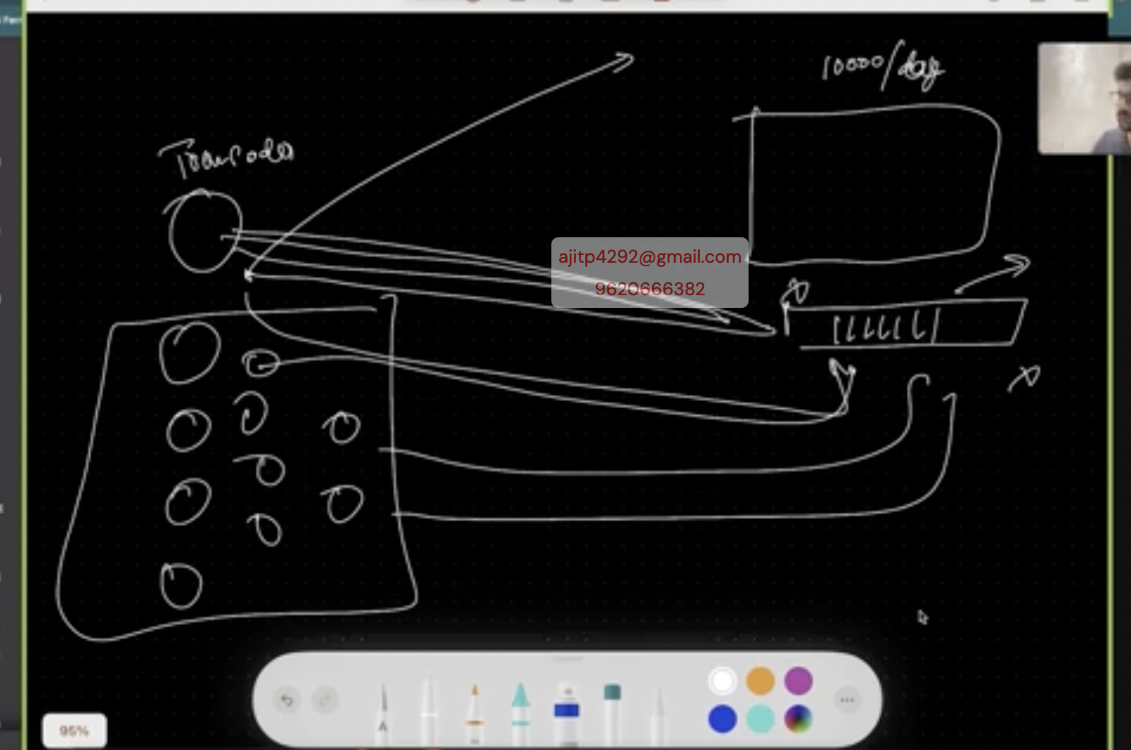

If auto scaled queue becomes empty then still transcoder instance running

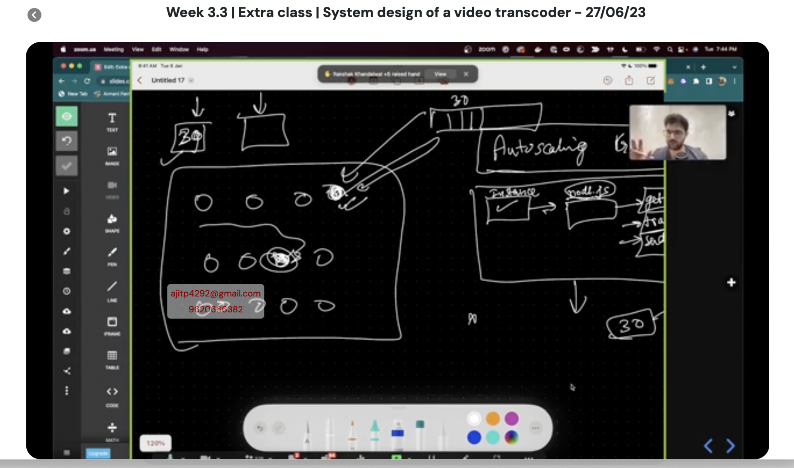

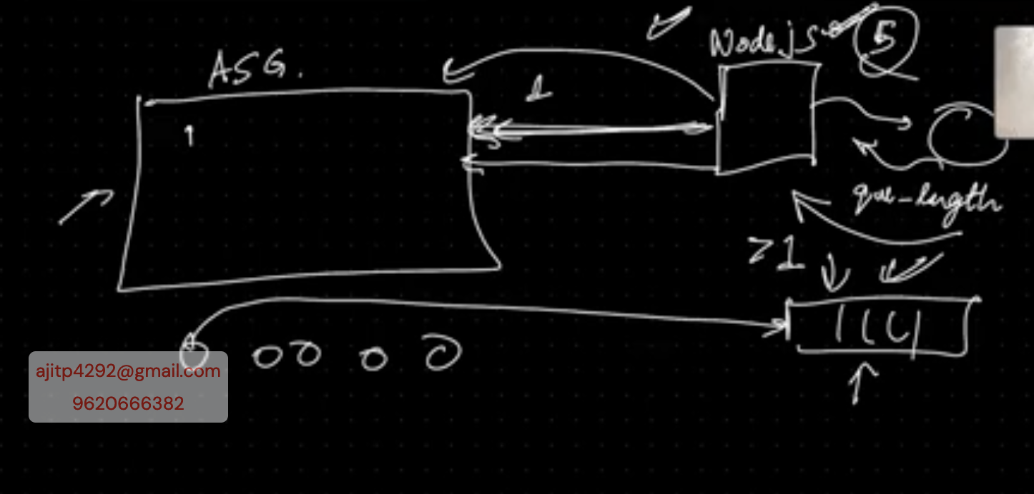

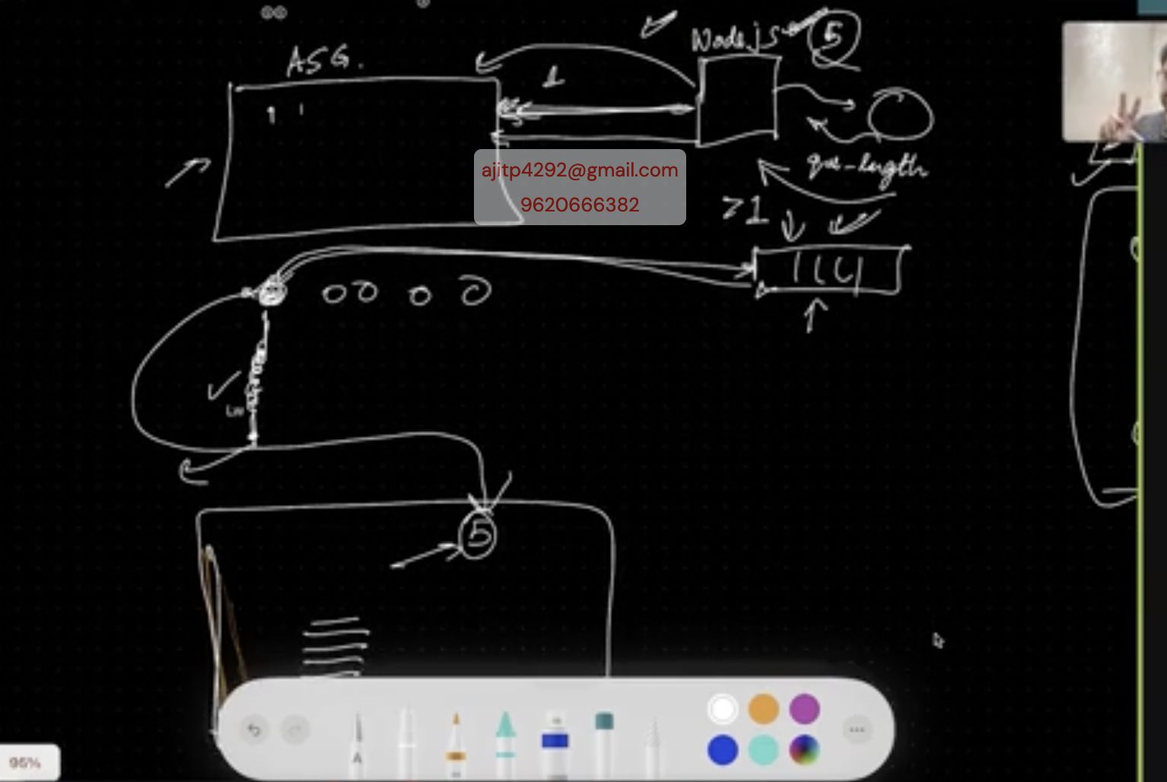

Optimal ways to handle

Buy upfront a bunch of servers like 50 for year